World Engineering Day – 2024 celebrated at MIT
World Engineering Day was celebrated at Manakula Vinayagar Institute of Technology by the Department of Mechanical Engineering and The Institution of Engineers India Puducherry MIT Students Chapter (Mechanical) on theme ENGINEERING SOLUTION FOR A SUSTAINABLE WORLD.
Shri.M.Dhanasekaran Chairman & Managing Director of Sri Manakula Vinayaga educational trust presided over the programme, Dr.K.Narayanaswamy, Secretary of Sri Manakula Vinayagar educational trust and Mr.D. Rajarajan ,Treasurer Sri Manakula Vinayaga educational trust felicitated the programme. Dr.S.Malarkkan, Principal, gave brief note about the program and Dr. B Radjaram, Head of the department, Mechanical Engineering honored & introduced the chief guest, Er. A. Jamaal Sharief, Quality Engineer, BOSCH Household Appliances Manufacturing Pvt Ltd, Chennai. The chief guest addressed the students about various quality techniques and importance of subject knowledge applied in industries.
The Guest Lecture Programmeis organized in this institution to create an impact among the young minds about Engineering applications in real life applications. The college and TheInstitution of Engineers (India) – Puducherry MIT Students Chapter Mechanical are conducting such special lecture programme as part of Institution’s social responsibility.

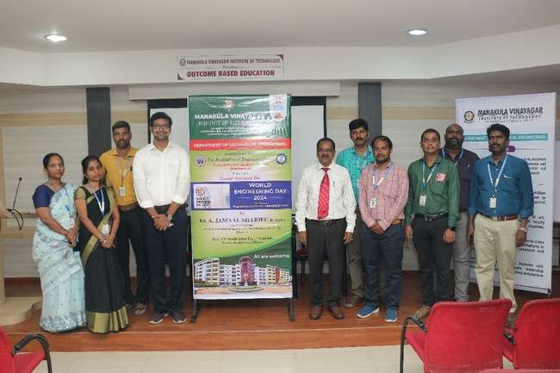
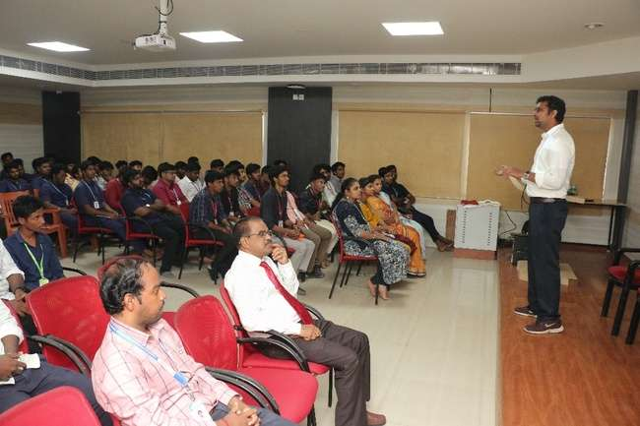
WORLD ENGINEERING DAY 24 PHOTOS

