DEPARTMENT OF MECHANICAL ENGINEERING
In Association with
ENERGY CLUB , MIT, PUDUCHERRY
A Guest Lecture on
Occupational Health and Safety for Engineers
By
Mr. K.VENGATESAN
HSE SPECIALIST / ADVISOR
GLOBAL SAFETY CONSULTING SERVICES, PUDUCHERRY
for
B.Tech (Mech , EEE, RAE & FT) Students
on
05.04.24 (Friday- 10.30 AM to 12.30 PM)
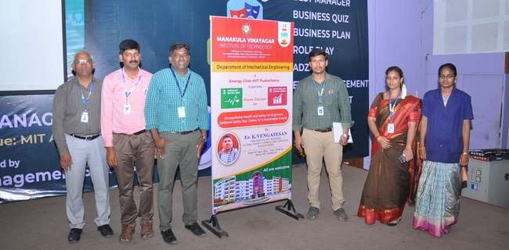
Submitted by
Mr.R.Ilandjezian
Assistant Professor, Mech,
ManakulaVinayagar Institute of Technology,
Puducherry.

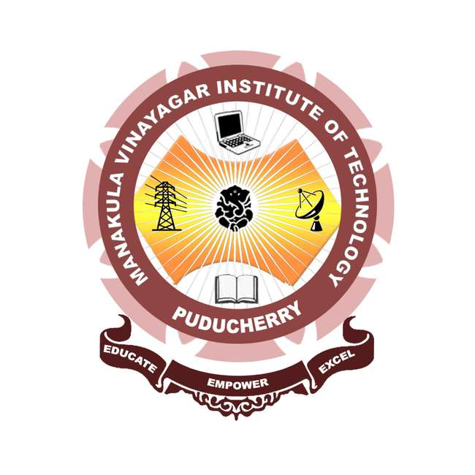

TABLE OF CONTENTS
S.NO | CONTENT
1 | REPORT
2 | CIRCULAR
3 | GUEST PROFILE
4 | ATTENDANCE
5 | FEED BACK
6 | PHOTOS

DEPARTMENT OF MECHANICAL ENGINEERING
ACADEMIC YEAR 2023-24 – ODD SEM
REPORT
TITLE OF THE PROGRAMME | A Guest Lecture on  Occupational Health and Safety for Engineers
RESOURCE PERSON | Mr. K.VENGATESAN  HSE SPECIALIST / ADVISOR  GLOBAL SAFETY CONSULTING SERVICES, PUDUCHERRY
TARGETED AUDIENCE | B.Tech (Mech , EEE, RAE & FT) Students
DEPARTMENT | Mech , EEE, RAE & FT II, III& IV Year
NO. OF STUDENTS ATTENDED THE PROGRAM | 200
VENUE | MIT -Auditorium
DATE &TIME | 05.04.24/ 10.30AM-12.30 PM

STAFF INCHARGE HOD

CHIEF GUEST PROFILE

Mr. K. Vengatesan has over 18 years of expertise in HSE management, risk assessment, HSE audits and trainings, occupational health and hygiene, hazardous waste management, and fire safety and security. He is an expert at inspecting and evaluating workplaces for fire and safety concerns, as well as recommending and implementing safe workplace processes and fire prevention and control measures. He also specialises in monitoring and controlling erection and shutdown, as well as preventative maintenance for columns, vessels, furnaces, pipelines, tanks, compressors, pumps, and other equipment. He focuses on preparing SHEMS manuals, maintaining safety papers, and upgrading ISO 14001 and ISO 45001 standards.
He provides instruction in areas such as monitoring safe big lifting operations, critical lifting, height work, confined space, and developing a rescue plan for all major operations. He also specialises in incident investigation, task risk assessment, permit to work (PTW), SIMOPS, job safety analysis, safety inspection-audits, HAZOP and HAZID, safety awareness programmes and trainings (on-the-job trainings, alerts, and safety campaigns). Experience developing HSE turnaround procedures, guidelines, emergency plans, SIMOPS, and other related documents. Compliant with international codes and norms, Authorised Gas Tester and Breathing Apparatus Train the trainers.

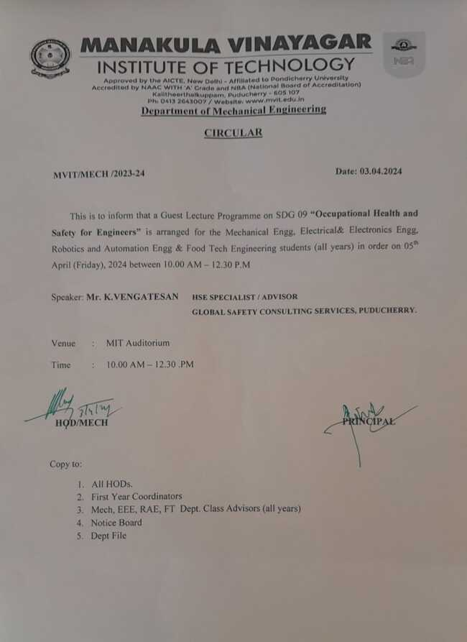

PHOTOS

